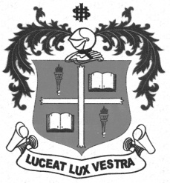
LOYOLA COLLEGE (AUTONOMOUS), CHENNAI – 600 034
B.A. DEGREE EXAMINATION – ECONOMICS
FIFTH SEMESTER – APRIL 2012

EC 5403 - LABOUR ECO. & LABOUR WELFARE

Date : 30-04-2012 Dept. No. Max. : 100 Marks
Time : 1:00 - 4:00

Part- A (5x4=20)

Answer any FIVE questions in about 75 words each:

- Define Labour market.
- What is meant by demand for and supply of labour?
- Write a short note on ‘Wage Differentials’
- Define Trade Union.
- What do you mean by industrial dispute?
- What is worker’s participation in management?
- Explain the term ‘social security’

Part- B (4x10=40)

Answer any FOUR questions in about 250 words each:

- Describe the wage structure in Indian Labour market.
- Explain Minimum wage Act-1948.
- What is meant by collective bargaining? Explain the role of it in determining wage.
- What do you mean by Strike? Explain the various types of strike.
- Explain the provision of Industrial dispute Act-1947
- Explain the subsistence theory of wage.
- Evaluate the Public provident fund Act-1968

Part- C (2x20=40)

Answer any TWO questions in about 900 words each:

- Explain the Payment of Bonus Act-1965
- Describe the present position of Trade Union in India.
- Suggest the measures to prevent the industrial disputes in India.
- Explain the Social security measures in India.

*************

